|  |  |  |  |
| --- | --- | --- | --- |
| **Ex. No. 1a** | **DESIGNING AN ENTERPRISE APPLICATION WEBSITE – E-Commerce** | | |
| Date of Exercise |  | Date of Output Verification |  |

**Aim**

To develop and deploy the enterprise application website for e-commerce using J2EE programming.

**Description**

An enterprise application is the phrase used to describe applications (or software) that a business would use to assist the organization in solving enterprise problems. When the word "enterprise" is combined with "application," it usually refers to a software platform that is too large and too complex for individual or small business use.

**Procedure**

* Open NetBeans IDE
* Open new Project window
* Choose java web /java EE
* Click next and specify name and choose the project location
* Click next and select the server
* Click finish
* Create index.jsp and make it as the index page in project properties
* Design the website using html, css, JavaScript
* Place header footer and body in different jsp files
* Link the file using jsp: include

**Program**

Header.jsp

<div class="container-fluid" id="header">

<ul class="nav nav-pills" id="header_menu">

<li class="active"><a data-toggle="pill" href="#Home">Home</a></li>

<li><a data-toggle="pill" href="#SignIn">Sign In</a></li>

<li><a data-toggle="pill" href="#SignUp">Sign UP</a></li>

<li><a data-toggle="pill" href="#AboutUs">About Us</a></li>

</ul>

</div>

Body.jsp

<%@page import="java.sql.DriverManager"%>

<%@page import="java.sql.ResultSet"%>

<%@page import="java.sql.Statement"%>

<%@page import="java.sql.Connection"%>

<%

Class.forName("org.apache.derby.jdbc.ClientDriver");

Connection con = DriverManager.getConnection("jdbc:derby://localhost:1527/J2EE-Lab-Experiments", "ws", "6477");

String query = "select category_name from ws.Exp1_categories_list";;

Statement st = con.createStatement();

ResultSet rs = st.executeQuery(query);

%>

<div class="tab-content">

<div id="Home" class="tab-pane active fade in">

<div style="background: rgba(0,0,0,0.3); margin: 30px; padding: 30px; border-radius: 5px;">

<ul id="menu">

<%while (rs.next()) {

out.write("<li><a>" + rs.getString(1) + "</a>"

+ "<ul><span><li>Item</li></span><span><li>Item</li></span></ul>"

+ "</li>");

}

%>

</ul>

<div class="test1" style=" width: 600px; background: blue; height: 300px; margin: 30px auto;">

<img src="images/1.jpg" id='slider' style="margin: 0 auto; width: 600px; background: blue; height: 300px;">

<p style=" margin: 0 auto; width: 100px;margin-top: -30px; color: white;">This is Text</p>

</div>

</div>

<div id="deals">

<ul class="nav nav-pills" style="margin: 0 auto; width: 500px;">

<li class="active"><a data-toggle="pill" href="#Electronics">Electronics</a></li>

<li><a data-toggle="pill" href="#Clothes">Clothes</a></li>

<li><a data-toggle="pill" href="#Shoes">Shoes</a></li>

<li><a data-toggle="pill" href="#More">More</a></li>

</ul>

<div class="tab-content" style="height: 250px;">

<div id="Electronics" class="tab-pane fade in active">

<%

for (int i = 1; i < 10; i++) {

%>

<div class="col-md-3 col-sm-4">

<a href="aa" class="thumbnail">

<p>Electronics</p>

<img alt="alt" src="images/home.jpg" width="50%">

</a>

</div>

<%

}

%>

</div>

<div id="Clothes" class="tab-pane fade">

<%

for (int i = 1; i < 10; i++) {

%>

<div class="col-md-3 col-sm-4">

<a href="aa" class="thumbnail">

<p>Clothes</p>

<img alt="alt" src="images/deals.jpg" width="50%">

</a>

</div>

<%

}

%>

</div>

<div id="Shoes" class="tab-pane fade">

<%

for (int i = 1; i < 10; i++) {

%>

<div class="col-md-3 col-sm-4">

<a href="aa" class="thumbnail">

<p>Shoes</p>

<img alt="alt" src="images/goods.png" width="50%">

</a>

</div>

<%

}

%>

</div>

<div id="More" class="tab-pane fade">

<%

for (int i = 1; i < 10; i++) {

%>

<div class="col-md-3 col-sm-4">

<a href="aa" class="thumbnail">

<p>More</p>

<img alt="alt" src="images/travel.jpg" width="50%">

</a>

</div>

<%

}

%>

</div>

</div>

</div>

</div>

<div id="SignIn" class="tab-pane fade main_block">

<form class="form-horizontal" style="margin-left: 160px;">

<p class="heading">Login</p>

<div class="form-group">

<label for="signin_email" class="control-label col-sm-3">Email</label>

<div class="col-sm-5">

<input type="email" id="signin_email" placeholder="Enter Email" class="form-control" required>

</div>

</div>

<div class="form-group">

<label for="signin_password" class="control-label col-sm-3">Password</label>

<div class="col-sm-5">

<input type="password" id="signin_password" placeholder="Enter Password" class="form-control" required>

</div>

</div>

<div class="form-group">

<div class="col-sm-offset-3 col-sm-10">

<button type="submit" class="btn btn-default">Login</button>

</div>

</div>

</form>

</div>

<div id="SignUp" class="tab-pane fade main_block">

<form class="form-horizontal" style="margin-left: 160px;" action="register.jsp" method="post">

<p class="heading">Sign Up</p>

<div class="form-group">

<label for="signup_fullname" class="control-label col-sm-3">Full Name</label>

<div class="col-sm-5">

<input type="text" name="signup_fullname" placeholder="Enter Full Name" class="form-control" required>

</div>

</div>

<div class="form-group">

<label for="signup_email" class="control-label col-sm-3">Email</label>

<div class="col-sm-5">

<input type="email" name="signup_email" placeholder="Enter Email" class="form-control" required>

</div>

</div>

<div class="form-group">

<label for="signup_dob" class="control-label col-sm-3">Date of Birth</label>

<div class="col-sm-5">

<input type="date" name="signup_dob" class="form-control">

</div>

</div>

<div class="form-group">

<label for="signup_Password" class="control-label col-sm-3">Password</label>

<div class="col-sm-5">

<input type="tel" name="signup_Password" placeholder="Enter Password" class="form-control" required>

</div>

</div>

<div class="form-group">

<label for="signup_confirm_Password" class="control-label col-sm-3">Confirm Password</label>

<div class="col-sm-5">

<input type="tel" name="signup_confirm_Password" placeholder="Confirm Password" class="form-control" required>

</div>

</div>

<div class="form-group">

<div class="col-sm-offset-3 col-sm-10">

<input type="submit" class="btn btn-default" value="SignUp" />

</div>

</div>

</form>

</div>

<div id="AboutUs" class="tab-pane fade main_block" >

<p class="heading">About Us</p>

Essays are generally scholarly pieces of writing giving the author's own argument, but the definition is vague, overlapping with those of an article, a pamphlet and a short story.

Essays can consist of a number of elements, including: literary criticism, political manifestos, learned arguments, observations of daily life, recollections, and reflections of the author. Almost all modern essays are written in prose, but works in verse have been dubbed essays (e.g. Alexander Pope's An Essay on Criticism and An Essay on Man). While brevity usually defines an essay, voluminous works like John Locke's An Essay Concerning Human Understanding and Thomas Malthus's An Essay on the Principle of Population are counterexamples. In some countries (e.g., the United States and Canada), essays have become a major part of formal education. Secondary students are taught structured essay formats to improve their writing skills; admission essays are often used by universities in selecting applicants, and in the humanities and social sciences essays are often used as a way of assessing the performance of students during final exams.

The concept of an "essay" has been extended to other mediums beyond writing. A film essay is a movie that often incorporates documentary film making styles and which focuses more on the evolution of a theme or an idea. A photographic essay is an attempt to cover a topic with a linked series of photographs; it may or may not have an accompanying text or captions.

</div>

</div>

Footer.jsp

<div id="footer" class="container-fluid" style="width: 100%; background: rgba(255,255,255,0.8); margin-top: 290px; height: 100px;">

<div style="color: white;

line-height:190%;

font-size:2em;

font-family:Calibri Light;

font-weight:600;

color:black;

text-align:center;

text-shadow: 1px 1px 4px #ffffff;

margin-top: 20px;

text-align:center;"> Developed by WS</div>

</div>

index.jsp

<!--

UR12CS135 - William Scott

Exp 1 - Designing an Enterprise Application Website

-->

<!DOCTYPE html>

<html>

<head>

<title>WS | J2EE | Exp 1</title>

<meta http-equiv="Content-Type" content="text/html; charset=UTF-8">

<link rel="stylesheet" type="text/css" href="Extensions/bootstrap-3.3.5-dist/css/bootstrap-theme.min.css">

<link rel="stylesheet" type="text/css" href="Extensions/bootstrap-3.3.5-dist/css/bootstrap.min.css">

<script type="text/javascript" src="Extensions/jquery-2.1.4.min.js"></script>

<script type="text/javascript" src="Extensions/bootstrap-3.3.5-dist/js/bootstrap.min.js"></script>

<link rel="stylesheet" type="text/css" href="style.css">

<script src="script.js" type="text/javascript"></script>

</head>

<body background="images/DSC_0216.jpg">

<jsp:include flush="true" page="header.jsp"></jsp:include>

<jsp:include flush="true" page="body.jsp"></jsp:include>

<jsp:include flush="true" page="footer.jsp"></jsp:include>

</body>

</html>

Register.jsp

<%--

Document : register

Created on : 17 Jul, 2015, 2:11:41 PM

Author : William Scott

--%>

<%@page contentType="text/html" pageEncoding="UTF-8"%>

<%@page import="java.sql.DriverManager"%>

<%@page import="java.sql.ResultSet"%>

<%@page import="java.sql.Statement"%>

<%@page import="java.sql.Connection"%>

<%

String name = request.getParameter("signup_fullname");

String email = request.getParameter("signup_email");

String dob = request.getParameter("signup_dob");

String pwd = request.getParameter("signup_Password");

String cnfpwd = request.getParameter("signup_confirm_Password");

Class.forName("org.apache.derby.jdbc.ClientDriver");

Connection con = DriverManager.getConnection("jdbc:derby://localhost:1527/J2EE-Lab-Experiments", "ws", "6477");

String query = "insert into ws.Exp1_Registered_user values('" + name + "', '" + email + "', '" + dob + "', '" + pwd + "')";

Statement st = con.createStatement();

int a = st.executeUpdate(query);

if (a == 1) {

out.print("Regestered Sucessfully");

} else {

out.print("Registration Error");

}

%>

Script.js

function signUpCheck() {

if ($("#signup_Password").val() == $("#signup_confirm_Password").val() && $("#signup_confirm_Password").val().length > 1)

alert("Sign Up Validated");

else

alert("Please Provide Proper Details");

}

$(document).ready(function () {

i = 1;

setInterval(function () {

// alert("a");

j = i;

i = (1 + i) % 6;

// alert(i + "" + j);

var src = $("#slider").attr("src").replace(j + ".jpg", i + ".jpg");

$("#slider").attr("src", src);

}, 3000);

});

Style.css

html{

overflow-x: hidden;

overflow-y: scroll;

}

body{

background-attachment: fixed;

}

#header li a,

#header li,

#header{

margin:0px;

border:0px;

margin:0px;

border-radius: 0px;

}

#header li{

width: 10%;

text-align: center;

background: rgba(0,0,0,0);

color: white;

line-height: 1em;

transition: background-color 0.5s ease;

}

#header li a{

background: rgba(0,0,0,0);

color: white;

transition: background-color 0.5s ease;

}

#header li.active a{

background: rgba(0,0,0,0.5);

color: white;

border-bottom: 2px solid white;

font-weight: 600;

border-radius: 3px;

transition: background-color 0.5s ease;

}

#header li:hover.active a{

background: rgba(0,0,0,0.5);

transition: background-color 0.5s ease;

}

#header li:hover a{

background: rgba(0,0,0,0.2);

border-radius: 3px;

color: white;

font-weight: 600;

transition: background-color 0.5s ease;

}

#header_menu{

position: relative;

left: 60%;

margin-top: 5px;

}

.heading{

padding: 10px;

font-size: 2.5em;

}

.main_block{

width: 70%; text-align: justify;

margin: 0 auto;

margin-top: 50px;

padding: 50px;

background: rgba(0,0,0,0.4);

border-radius: 10px;

color: white;

}

#deals .tab-content{

margin: 20px 50px;

}

#deals li{

width: 100px;

margin: 2px;

text-align: center;

border-bottom: 1px solid white;

}

#deals a{

color:white;

background: rgba(0,0,0,0.3);

transition: background-color 0.5s ease;

}

#deals li:hover a{

color: white;

background: black;

transition: background-color 0.5s ease;

}

#deals li:hover.active a{

color:white;

background: black;

transition: background-color 0.5s ease;

}

#deals li.active a{

font-weight: 600;

background: black;

transition: font-weight 0.5s ease;

/*border-bottom: 1px solid white;*/

}

#Home ul li ul{

display: none;

visibility: hidden;

}

#menu{

/*width: 50%;*/

}

ul#menu > li{

display: inline-block;

cursor: auto;

padding: 0px;

margin: 0px;

border: 0px;

/*width: 10%;*/

text-align: center;

background: rgba(0,0,0,0.5);

border-bottom: 1px solid white;

padding: 10px 20px;

border-radius: 4px;

margin: 5px;

}

#menu li:hover{

background: black;

color: white;

transition: background-color 0.5s ease;

cursor: pointer;

}

#menu a{

text-decoration: none;

cursor: auto;

color: white;

cursor: pointer;

transition: background-color 0.5s ease;

}

#Home ul li:hover > ul li:hover{

background: rgba(255,255,255,0.2);

font-weight: 600;

}

#Home ul li:hover > ul li{

border: 1px solid white;

border-radius: 3px;

padding: 5px 10px;

margin:5px 10px;

margin-left: -30px;

background: black;

width: 60px

}

#Home ul li:hover > ul{

visibility: visible;

display: block;

transition: display 1s ease;

transition: visibility 1s ease;

position: absolute;

background: rgba(0,0,0, 0.6);

margin-top: 10px;

margin-left: -10px;

/*padding: 20px;*/

list-style: none;

}

**Output**

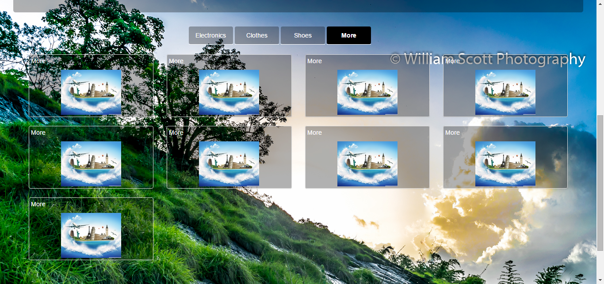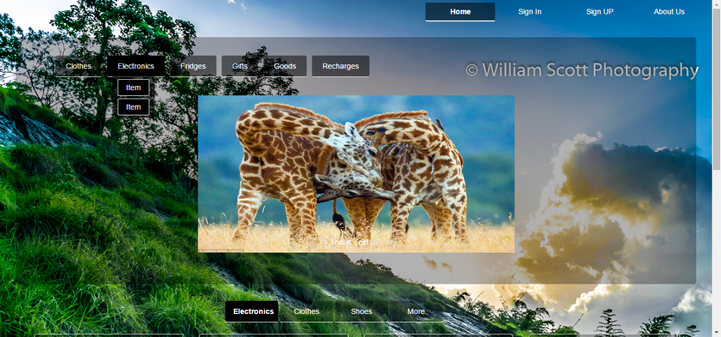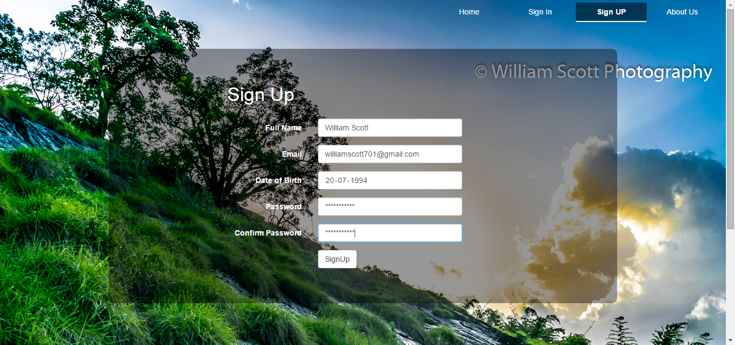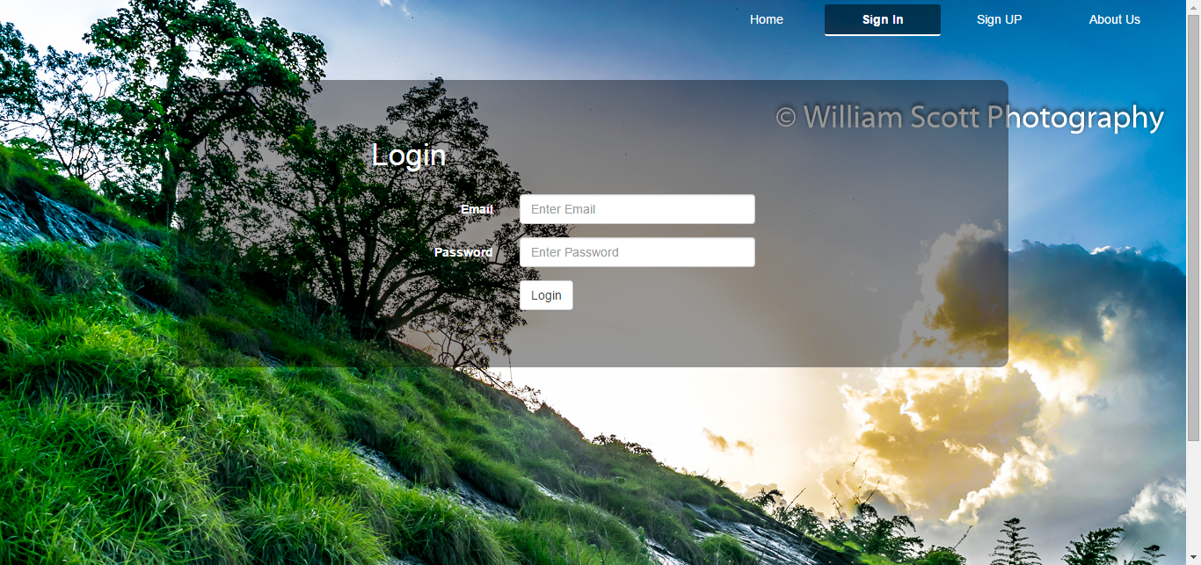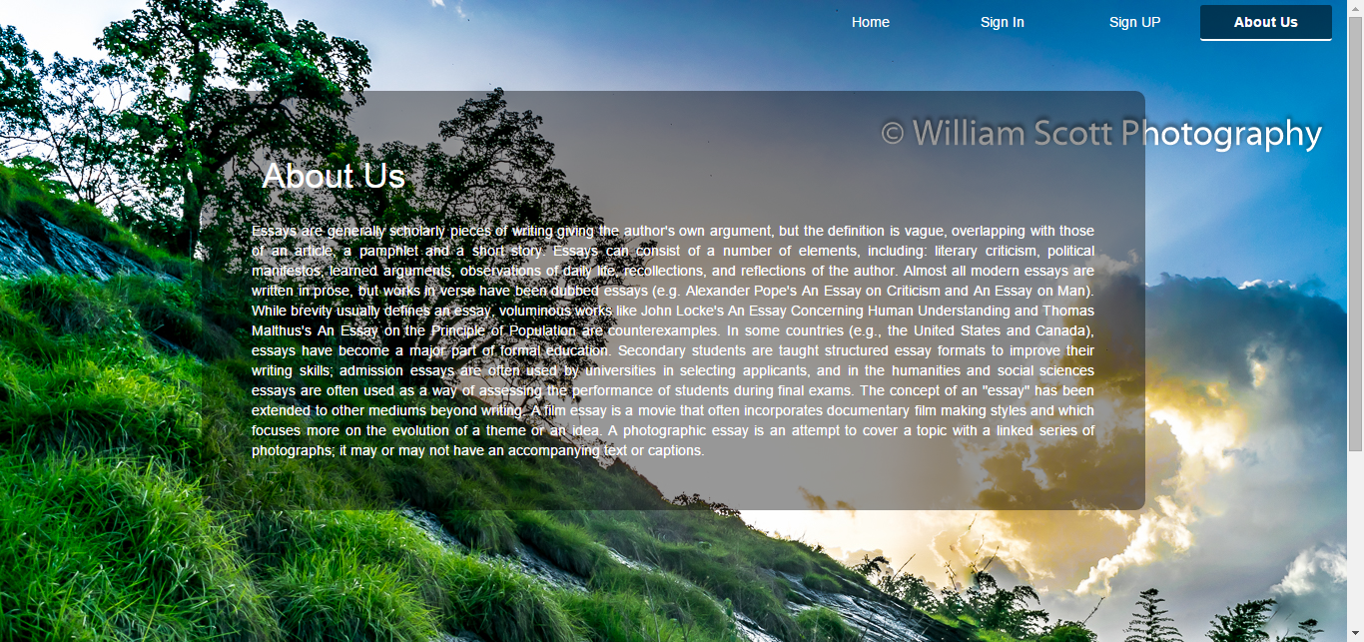

**Result**

Thus, the enterprise application website for e-commerce was successfully developed and deployed

[Signature of the Staff In-charge]

[Name of the Staff In – charge]